

**CS463-Natural Language Processing**

**Project Report**

**GPT Sentiment Analysis**

**Prepared by:**

|  |  |  |
| --- | --- | --- |
| Name | ID | Department |
| Ahmed Gamal Ahmed | 20190021 | Computer Science |
| Ahmed Adel Hamed | 20190042 | Computer Science |
| Zeyad Maher Mahmoud | 20190224 | Computer Science |

**Prepared for:**

Dr. Hanaa Bayoumy

TA. Laila Mostafa

**Model-1 CNN**

**Graph of Trials & Accuracy:**

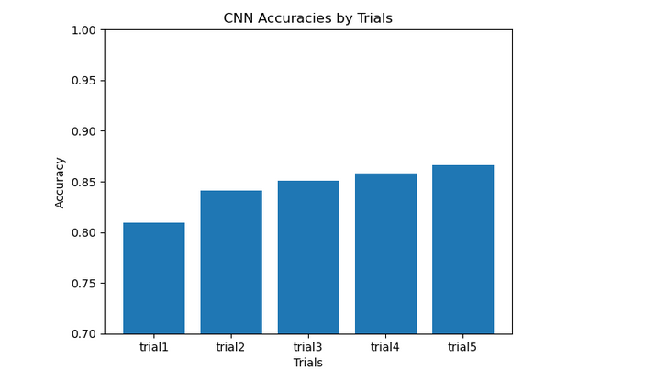

1st trial: 10 epochs, 32 batch_size

Layers: input,embedding, conv, pooling, dense,dropout(50%),output

testing acc: 80.9%

2nd trial: 10 epochs, 128 batch_size

Layers: input,embedding, conv, conv,dropout(25%),conv, global max pooling,output

change batch size, adding conv layer, change percent of dropout neurons

testing acc: 84.07%

3rd trial: 10 epochs, 64 batch_size

Layers: input, embedding, conv, conv, maxpooling, droupout, conv, max pooling, conv, maxpooling, dense ,dropout, output

change batch size. Adding conv, maxpooling, dropout layers

testing acc: 85.04%

4th trial: 15 epochs, 32 batch_size

Layers: input, embedding, conv, conv, maxpooling, droupout, conv, max pooling, conv, maxpooling, dense ,dropout, output

change epochs,batch size.

testing acc: 85.78%

5th trial: 5 epochs, 256 batch_size

Layers: input, embedding, conv, drouput, conv, maxpooling, droupout, conv, max pooling, conv, globalmaxpooling, dense ,dropout, output

change epochs,batch size. Adding dropout layer.

testing acc: 86.59%

**Users Inputs on new Tweets:**

**Best CNN Model**

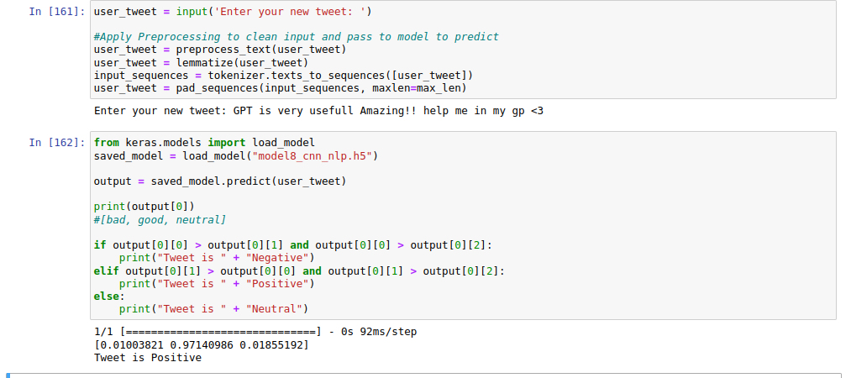

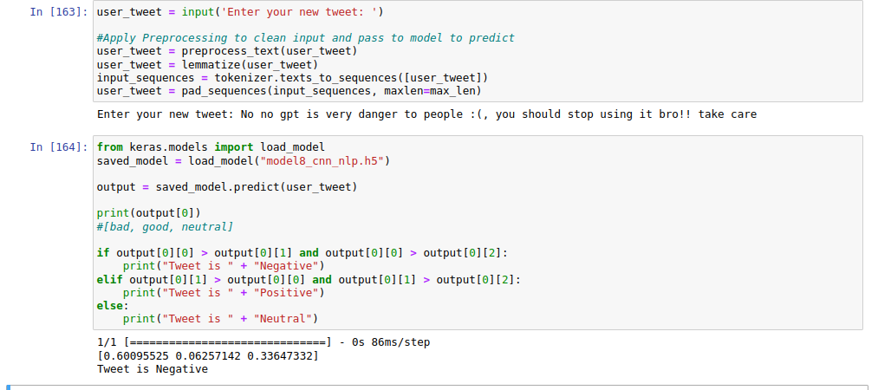

**Best Accuracy Result:**

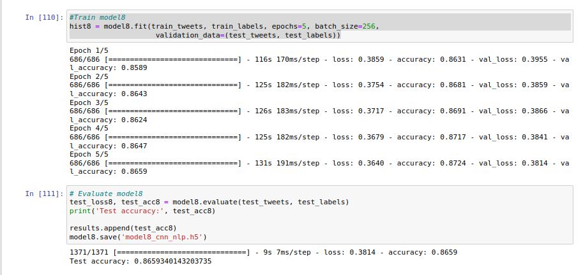

Model Architecture:

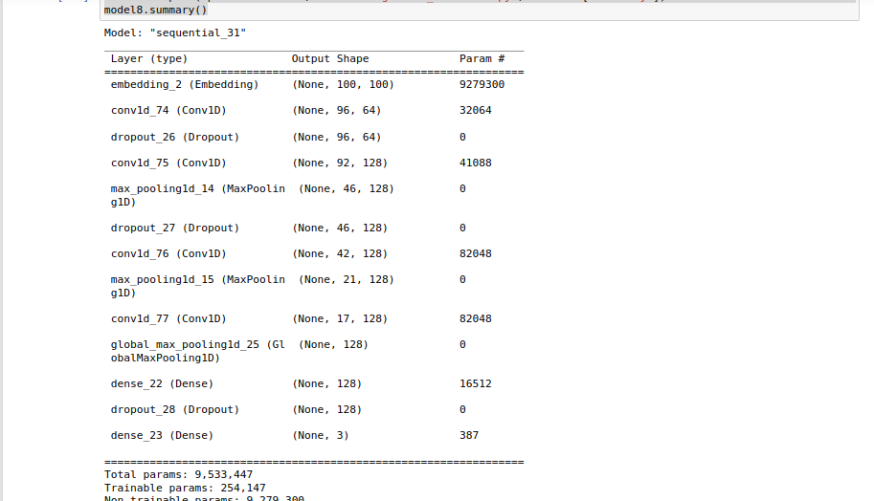

**Model-2 RNN (LSTM)**

**Graph of Trials & Accuracy:**

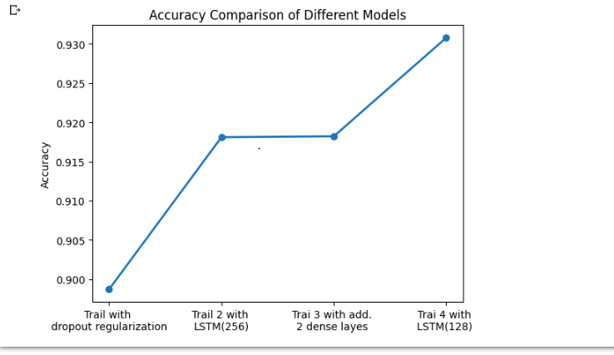

1st model : This model takes a sequence of integers as input, applies an embedding layer to convert them into dense vectors, processes the embedded sequences using two LSTM layers, applies a dense layer with ReLU activation, and finally outputs the predicted probabilities for each class using a softmax activation. We used LSTM with 256 hidden units and made Dropout regularization (0.5)and then another LSTM with 256 hidden units. Ran on 5 epochs.

2nd model : We used same model 1 but without the regularization step which take us to a model of 2 LSTM(256) layers with dense layer with ReLU activation function . ran on 5 epochs also.

3rd model : We enhanced the model by adding additional 2 dense layers at the end of so we put a layer Dense(256) then the previous dense(128) as it is and then Dense(64), to lead finally to the layer Dense(3) that uses the softmax activation function that produce the decision of good, neutral or bad .

4th model : this is the best model so far , we produced it by replacing the 2 layers of LSTM (256) by 2 layers LSTM(128) which made a big difference in the results and produced more efficient model with 93% accuracy.

**Users Inputs on new Tweets:**

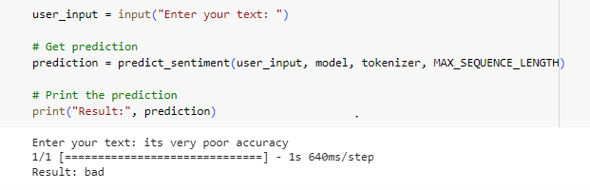

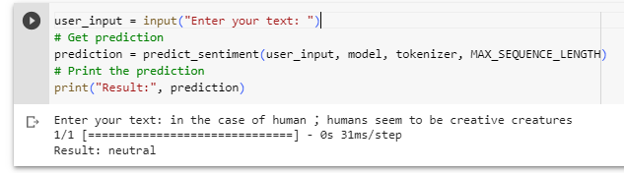

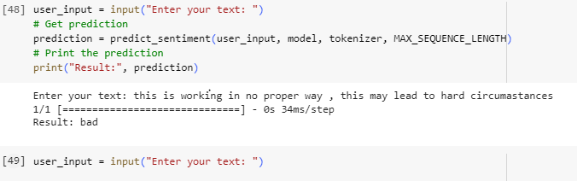

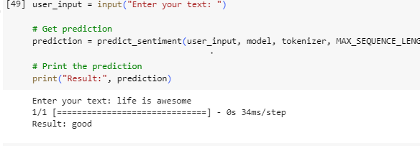

**Best Accuracy Result:**

**93%**

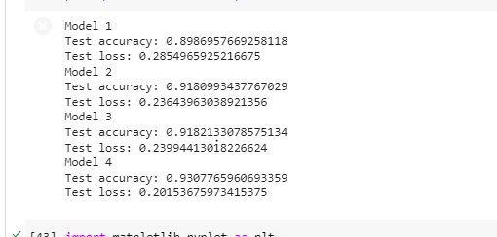

Model Architecture.

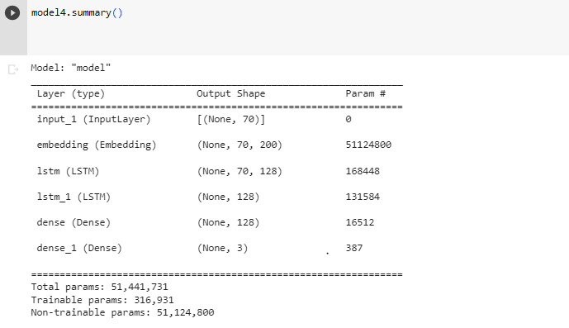

**Thank You !!**